**CHALLENGE – 03**

**1.Write a bash script to find the latency from the sample nginx log file.**

**--Bash script should only print the latency.**

--File (log_test.csv) copied from windows to linux

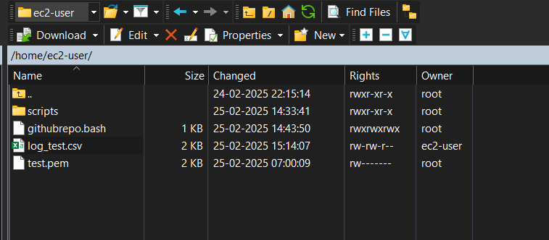

--Script used to print the latency column

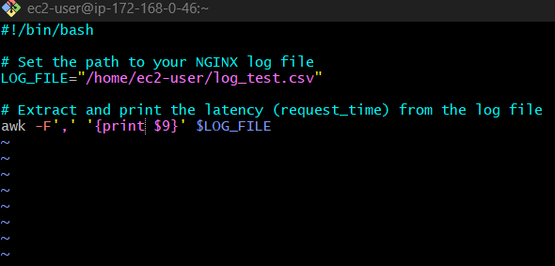

--Output

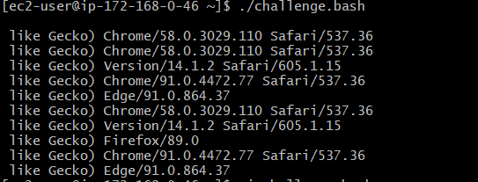

**2. Bash Script to create repo in github:**

--Script used to create the repo

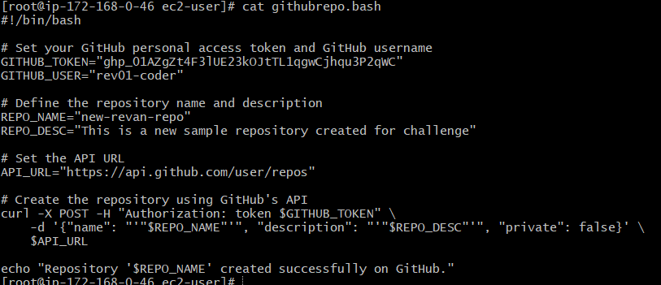

**--Output :**new repository named “new narendar-20 repo” has been created in github

